Number Guessing Game   
Console App

In this mini project, we will create a Number Guessing Game console application. The objective of the game is to guess a randomly generated number within a specified range. The player will be given a limited number of attempts to guess the correct number.

**Requirements:**

1. The program should generate a random number within a specified range.
2. The player should be prompted to enter their guess.
3. The program should provide feedback to the player if their guess is too high or too low.
4. The player should be given a limited number of attempts.
5. If the player guesses the correct number, the program should display a congratulatory message and the number of attempts taken.
6. If the player exhausts all attempts without guessing the correct number, the program should display a message indicating the end of the game.

Example gameplay:

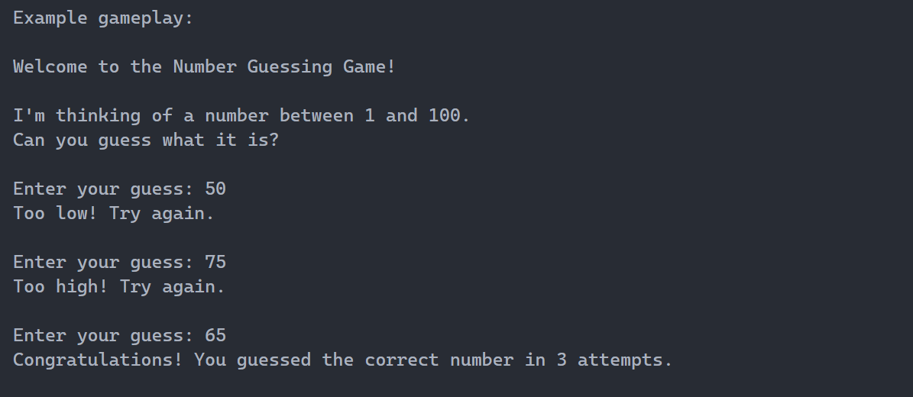

The code for this project will involve generating a random number, handling user input, comparing the guess with the target number, and keeping track of the number of attempts.

Are you ready to dive into the Number Guessing Game project? Let's get started! Happy coding!